**PRACTICAL-1.4**

**AIM:**

Find a subset of a given set S={s1,s2,.....,sn} of n positive integers whose sum is equal to a given positive integer d. For example, if S= {1, 2, 5, 6, 8} and d = 9 there are two solutions {1,2,6} and {1,8}.A suitable message is to be displayed if the given problem instance doesn't have a solution.

**PROGRAM CODE:**

#include <iostream>

using namespace std;

static int counter = 0;

bool isSubsetSum(int set[], int n, int sum)

{   counter++;

    if (sum == 0)

    return true;

    if (n == 0 && sum != 0)

        return false;

    if (set[n -1] > sum)

         return isSubsetSum(set, n -1, sum);

    return isSubsetSum(set, n -1, sum) || isSubsetSum(set, n -1, sum -set[n -1]);

    }

int main()

{

    int n;

    int sum;

    cout<<"Enter the size of array : ";

    cin>>n;

    int set[n];

    cout<<"Enter the elements : ";

    for(int i=0;i<n;i++)

    cin>>set[i];

    cout<<"Enter the sum : ";

    cin>>sum;

    if (isSubsetSum(set, n, sum) == true)

        cout <<"SUBSET EXISTS"<<endl;

    else

        cout << "NO SUBSET EXISTS"<<endl;

        cout <<"Counter : " << counter<<endl;

        cout <<endl;

        cout<<"PARTH PATEL 19DCS098"<<endl;

        return 0;

}

**OUTPUT:**

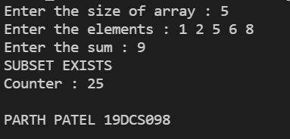

**TABLE:**

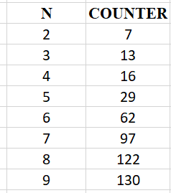

**GRAPH:**

